

2425 BIS Postgraduate Project: Research Skill Final Derivable

I have read the University’s code of practice on plagiarism/University’s Academic Integrity policy QA220. I know that plagiarism is wrong. I hereby certify that this material, which I submit for assessment on the program of study leading to the award of an MSc degree, is entirely my own work. It has not been taken from the work of others, except to the extent that such work has been cited and acknowledged within the text of my work. All materials used are paraphrased appropriately or enclosed with quotation marks. I also recognize that collusion is wrong. I have not allowed and will not allow anyone to copy my work with the intention of passing it off as their own. I also acknowledge that copying someone else’s assignment (or part of it) is wrong and declare that my assignments are entirely my own work.

Student Name | Student ID | Signature
Pooja Manjarekar | 24240124 | 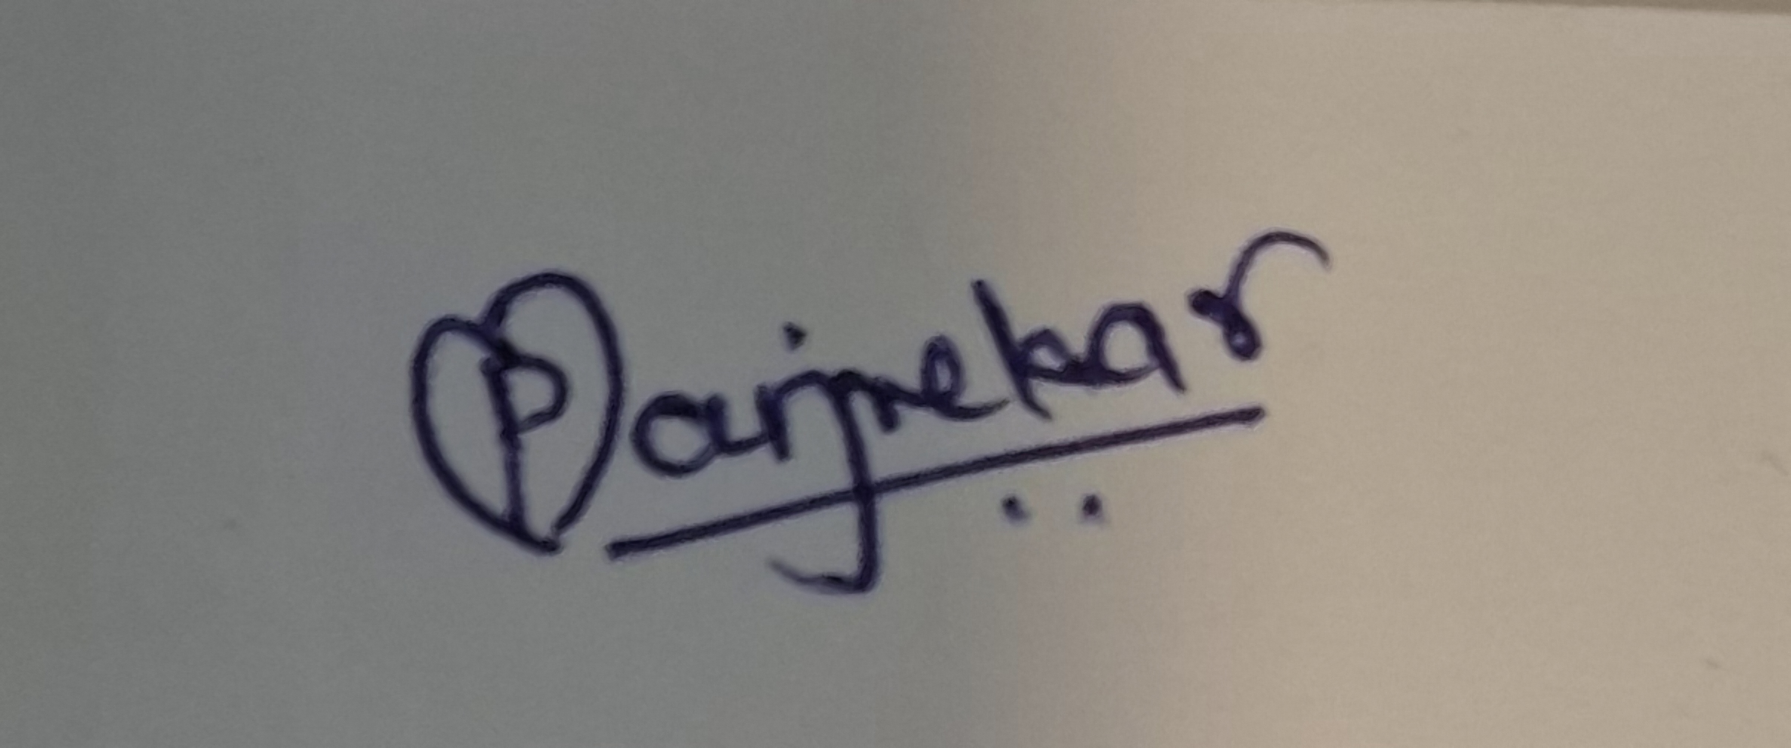
Shubham Bhatnagar | 24238834 | 
Amit Kumar | 24236930 | 
Akshata Ghumatkar | 24240627 | 

Table of Contents
Introduction 3
Background 4
Concept and Philosophy of MMM 4
Strategic Value of MMM to Business 5
Comparison to Multi-Touch Attribution (MTA) 6
Why MMM is Crucial for F-Kart 6
Methodology 8
Data Sources and Structure 8
Data Cleaning and Preprocessing 8
Feature Engineering 8
Standardization and Encoding 9
ModelLing Techniques 9
Model Evaluation Strategy 11
Results and Analysis 12
Home Audio 12
Camera Accessories 13
Gaming Accessories 13
Comparative Summary of Model Performance 14
Business Insights Across Categories 14
Category Comparison: Why Gaming Accessories Lead 15
Visual Insight Summaries (EDA Support) 15
Strategic Recommendations 17
Segment-Specific Strategy: Priority to Gaming Accessories 17
Lag-Aware Campaign Planning Across Categories 17
Pricing and Discount Strategy 18
Product-Centric Targeting 18
Media Investment Optimization 18
Operational Enhancements 19
Dashboard and Automation 19
Category-Specific Summaries 19
Limitations and Future Work 20
Modelling Assumptions and Simplifications 20
Lag and Adstock Handling 20
Data Constraints 20
Future Directions 21
References 22
Appendix 22

Marketing Mix Modelling to Optimize Marketing Performance: A Study of F-Kart’s Home Audio, Camera, and Gaming Accessory Categories

Introduction

The study analyses the performance of past marketing campaigns and designs evidence-based recommendations for future planning using Marketing Mix Modelling (MMM) for F-Kart, an e-commerce retail company. Focusing on three pillar product categories, Home Audio, Camera Accessories, and Gaming Accessories, the project applies sophisticated regression models to quantify the determinants of Gross Merchandise Value (GMV) and inform marketing investment decisions.

A complete dataset from July 2023 to June 2024 was analysed. Preprocessing techniques included correlation filtering, scaling, one-hot encoding, and lag/adstock transforms for improving model performance. Various model techniques were tried: Linear Regression, OLS, Recursive Feature Elimination (RFE), Adstock-transformed OLS, Gradient Boosting with Koyck lag, Distributed Lag Models (DLM), and Exponential/Multiplicative OLS regressions.
Out of all the models, the Exponential/Multiplicative model for Gaming Accessories fit with the highest R² of 0.8592 and lowest RMSE of 0.3334, detecting leading GMV drivers such as product MRP, units sold, and marketing lag variables such as LP_lag_2_per. The Distributed Lag Model performed extremely well across categories, especially for Home Audio (R² = 0.794) and Gaming Accessories (R² = 0.8016), indicating strong evidence of strong temporal effects on campaign performance.

Key findings are that:
- Discounts often negatively impact GMV, showing price sensitivity.
- Delayed marketing effects (1–3 weeks) significantly influence sales.
- High-MRP, niche gaming products generate the highest returns when combined with smart campaign timing.

Recommendations involve actionable actions such as lag-aware media planning, controlled discounting, bundling high-performing products, and anticipatory inventory alignment. Weaknesses are linearity assumptions within models, exclusion of interaction terms, and reliance on historical data. Emerging directions involve the integration of Bayesian MMM or machine learning models for better personalization and accuracy.

This MMM project demonstrates statistical modelling can be employed to link marketing efforts and business outcomes, providing data-driven strategy for maximizing ROI in an intense, privacy-constrained retail environment.

Background

Marketing Mix Modelling (MMM) is quantitative analytical technique used to measure effectiveness of marketing strategy and guide future investment. It is a key tool in today's business, where marketing budgets need to be justified on an ongoing basis and traditional tracking vehicles no longer work due to growing issues of privacy. With escalating limits on user-level data (e.g., cookies deprecation, GDPR), marketers are turning to MMM for reliable insights respecting privacy on how different variables affect business outcomes (Bricker, 2024).

Concept and Philosophy of MMM

MMM rests on the "marketing mix" idea, originally put forward by Borden in the 1940s and later made famous as the 4Ps - Product, Price, Place, and Promotion (Lilien et al., 1992). It uses statistical modelling, usually regression analysis, to quantify the relative contribution of every marketing mix element towards sales or revenues outcomes. In contrast to digital models based on one-to-one interactions, MMM uses aggregated historical data to determine long-term trends, media interactions, and decreasing returns (DataCamp, 2024). Over the last few years, MMM has experienced a resurgence as it is immune to privacy changes and can even measure cross-channel effects (NielsenIQ, 2020). With marketers shifting away from real-time attribution towards strategic planning, MMM provides a better panoramic view that allows marketers to connect marketing decision-making to overall business goals.

It addresses some of the key questions such as "What is the ROI of each marketing channel? ", "What if we reallocated our media spend? ", and "How do we plan to spend to get the most return?"

Strategic Value of MMM to Business

MMM serves three main roles for businesses:
- Scorekeeping – Monitoring the overall contribution of marketing to business performance.
- Forecasting – Quantifying the impact of marketing input fluctuations.
- Optimization – Recommending budget allocation across channels to maximize ROI (Supermetrics, 2024).

These functions serve a pivotal function in omnichannel environments like e-commerce, whereby sales are impacted by the mix of online and offline activity, promotions, pricing, seasonality, and outside elements like holidays or competition. MMM provides a rigorous framework through which to quantify the effect of these variables and generate data-driven recommendations.
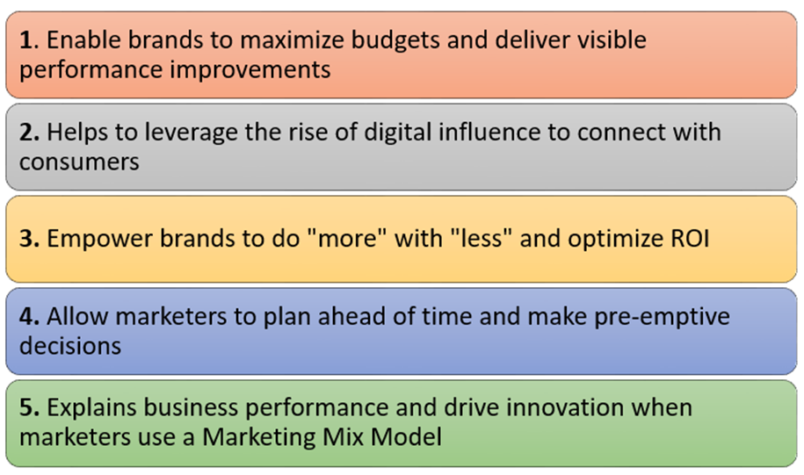
Figure 1: five reasons why measuring marketing ROI is essential for brand success.

Figure 1 depicts an infographic by NielsenIQ (2020) listing five reasons why MMM remains meaningful today: ROI optimization, working together under constrained budgets, avoiding privacy and attribution challenges, enabling fast strategy shifts, and assisting in full marketing impact comprehension.

In our study, we use MMM for the purpose of understanding what is influencing the Gross Merchandise Value (GMV) of F-Kart, an e-shopping firm, in three categories: Home Audio, Camera Accessories, and Gaming Accessories. Using various regression techniques on time series data from July 2023 to June 2024, the aim here is to identify the drivers of growth as well as forecast future performance under different scenarios.

Comparison to Multi-Touch Attribution (MTA)

Even though Multi-Touch Attribution (MTA) models have gained widespread application in digital marketing, their reliance on user-level data deems them less and less accurate. Figure 1 below clarifies differences between MMM and MTA.
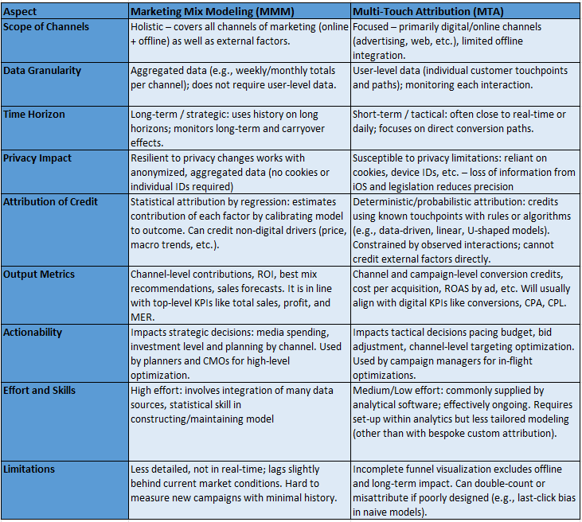
Figure 1: Comparison of Marketing Mix Modelling and Multi-Touch Attribution

As the marketing environment becomes increasingly complex and privacy-first, MMM delivers a future-proof and comprehensive measurement solution. It enables CMOs and marketing analysts to make data-driven decisions even in the absence of granular tracking (Gartner, 2024).

Why MMM is Crucial for F-Kart

F-Kart's challenge is how to allocate its marketing budget efficiently between product categories and channels without sacrificing profitability and customer demand. With competition, price wars, and changing customer behaviour, the previous method of intuition-driven decision-making will no longer be effective.

With MMM, F-Kart gains the ability to:
- Differentiate between baseline GMV (sales attributable to brand equity or organic traffic) and incremental GMV (sales attributable to marketing).
- Estimate the ROI of each marketing activity—TV ads, online campaigns, digital media spend, and discount promotions.
- Detect lagged effects where marketing activities today influence GMV in future weeks.
- Identify saturation points and diminishing returns on ad spend.
- Develop forward-looking plans with simulated "what-if" scenarios.

This corroborates evidence from practitioner and academic literature. In a recent report, Gartner wrote that MMM is "a game-changer for maximizing ROI, creating channel synergy, and making smarter, data-driven decisions" (Gartner, 2024).

In brief, MMM's ability to quantify and optimise marketing effect over time, across channels, and by product makes it an essential tool for the business of today. Its strength lies in its unification of historical performance data and strategic forecasting, offering insight along with foresight.

Methodology

The methodological approach used in modelling Gross Merchandise Value (GMV) of three product categories Home Audio, Camera Accessories, and Gaming Accessories using Marketing Mix Modelling (MMM). The process included data collection, cleaning, transformation, and deployment of different regression-based models. The overall objective was to identify the most impactful marketing and operational drivers of GMV, using statistical modelling to simulate real-world marketing effects.

Data Sources and Structure
Data were procured from F-Kart's internal transactional and marketing records between July 2023 and June 2024. It was given in three separate files, each for a different product category. The datasets contained weekly aggregated information on:

- Product sales (units sold, MRP, discounts)
- Marketing spends (TV, digital, online, radio, content marketing)
- Operational attributes (delivery time, SLA compliance, procurement lag)
- Customer behaviour (payment method, holiday flags)
- Time-based lag variables (LP lag, PO lag, GMV lag)

The target variable across the datasets was GMV, the total merchandise value generated each week. Each dataset contained over 90,000 observations to ensure sufficient granularity for regression analysis.

Data Cleaning and Preprocessing
Loaded data using pandas, with encoding set to 'latin-1' to account for special characters. Carried out structural validation using head() and info() functions. Constant columns, missing values, and extreme outliers were identified using ydata-profiling, enabling a systematic cleaning process. Highly correlated features (correlation > 0.8) such as overlapping marketing spend features were identified from a heatmap created with seaborn. Redundant features were dropped to prevent multicollinearity and inflated coefficients with a masked correlation matrix. Model stability and interpretability were improved consequently.

All infinite values were replaced with NaN using .replace([np.inf, -np.inf], np.nan) and then dropped using .dropna(). Columns containing redundant missing or constant values, such as order IDs or stationary flags, were dropped.

Feature Engineering
To model consumer behaviour more realistically, lag and moving average features were engineered:
- gmv_lag1, gmv_lag2, gmv_lag3: Previous weeks' GMV
- inc_LP_MA1: Moving average of incremental landing page performance
- LP_lag_2_per, PO_lag_1_per: Lagged promotional and order values

These features helped capture lagged marketing impacts, a common phenomenon in MMM (DataCamp, 2024).

Standardization and Encoding
Numerical features were standardized using StandardScaler to reduce scale differences. Categorical features such as ItemType and Delivery_Status were encoded using OneHotEncoder. A ColumnTransformer pipeline was applied for reproducible and efficient preprocessing.

ModelLing Techniques
We applied various regression techniques for complete exploration. Each model was tested separately on the three datasets. The models are:

Linear Regression (Baseline Model)
Utilizing sklean.linear_model.LinearRegression, the model was fit to predict direct linear correlations between predictors and GMV. It was a comparison/interpretation baseline.

Metrics for evaluation: R² Score, RMSE
Results: Performed reasonably well, best in Gaming Accessories (R² = 0.64)

Ordinary Least Squares (OLS) Regression
Using statsmodels.OLS, OLS regression gave us coefficients, p-values, and confidence intervals for all the predictors. This proved particularly useful in identifying statistically significant variables.

Metrics Used for Evaluation: Adjusted R², RMSE, p-values

Recursive Feature Elimination (RFE)
Implemented via sklearn.feature_selection.RFE, this technique selected the 10 most predictive features by recursively eliminating the least important ones.

Goal: Minimize overfitting and enhance model generalization
Use Case: Variables input into an OLS model to contrast performance
Outcome: Reduced model complexity, with sacrifice in accuracy

Adstock Transformation with OLS
Media spend metrics like TV, Digital, and Online Marketing were transformed via the adstock formula to capture decaying influence through time:

Adstockt=Spendt+λ×Adstockt−1Adstockt =Spendt +λ×Adstockt−1

In this equation, λλ is the decay rate, typically between 0.5 and 0.8.
Tool Used: Custom Python function + statsmodels.OLS
Impact: Media memory effects on captured media

Gradient Boosting with Koyck Lag Modeling
We applied GradientBoostingRegressor with RFE to choose the best features and then employed the Koyck model with statsmodels.OLS:

GMVt=α+β1⋅Xt+β2⋅GMVt−1+ϵGMVt =α+β1 ⋅Xt +β2 ⋅GMVt−1 +ϵ

This allowed short-run lag modelling at low complexity.
Strength: Effected delayed marketing impact effectively
Performance: Moderate; best in Gaming (R² = 0.601)

Distributed Lag Model (DLM)
Built using stepwise regression after constructing several lag variables (1 to 3 weeks), the DLM model captured cumulative lag effects on GMV.

Variables: gmv_lag1, inc_LP_MA1, PO_lag_2_per, etc.
Evaluation: R² and RMSE on test data
Best Results: Gaming Accessories (Test R² = 0.8016)

Exponential/Multiplicative Regression Model
All numeric variables were log-transformed using log1p() to capture multiplicative effects, suitable for interpreting elasticities:

log⁡(GMV)=β0+β1⋅log⁡(X1)+β2⋅log⁡(X2)+⋯+ϵlog(GMV)=β0 +β1 ⋅log(X1 )+β2 ⋅log(X2 )+⋯+ϵ

Model: OLS with log-log specification
Use Case: Best fit for % change comprehension
Top Performer: Gaming Accessories (R² = 0.8592)

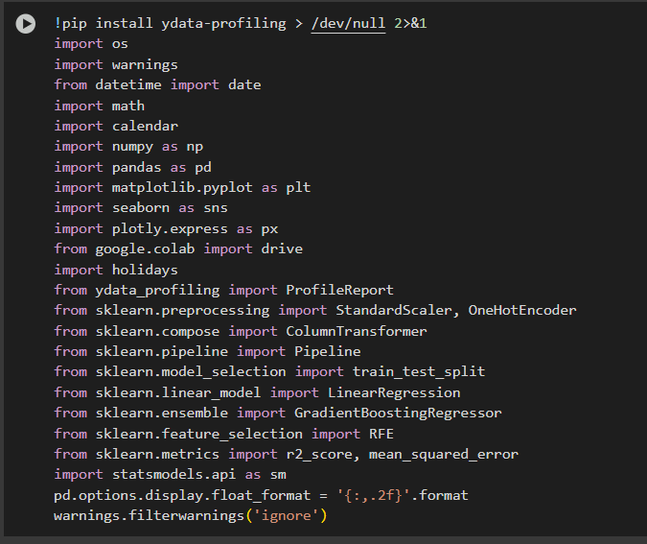
Figure 2: Libraries

Model Evaluation Strategy
To ensure fairness and accuracy across models:
- All models were trained on 80% of the data and tested on the remaining 20%.
- Performance was measured using:
- R² and Adjusted R²: For variance explanation
- RMSE: For predictive accuracy
- p-values: For feature significance
- Consistency across product categories was maintained by applying identical preprocessing and evaluation steps.

Results and Analysis
We display performance and interpretation of various models applied to the three product categories: Home Audio, Camera Accessories, and Gaming Accessories. Each subsection includes business insights, key variables, R², RMSE, feature importance, and interpretation. We also compare model outputs to decide the effectiveness of various marketing strategies by category.

Home Audio

Linear and OLS Models

The Linear Regression model gave an R² of 0.4472. This indicates that nearly 45% of the GMV variation was explained with linear relationships. The OLS model could improve this fit to ~0.61 adjusted R² with RMSE of 0.58. Important predictors were:
- Discount_Percentage (negative impact)
- TV_Adstock (positive, lagged impact)
- Units Sold
- Delivery_on_time
- SoundMixer, DJController (product sub-types)
Explanation: TV media spends, and on-time delivery significantly positively influenced GMV, while heavy discounting always negatively influenced it. The presence of some product verticals reflected consumer preference.
Distributed Lag Model (DLM)

The DLM of Home Audio had one of the best fits:
- Adjusted R² (Train) = 0.818
- Test R² = 0.794
- Test RMSE = 0.4561

Key lagged variables: gmv_lag1, gmv_lag2, inc_LP_MA1
Product subtypes like DJController had significant positive coefficients

Interpretation: Sales and campaigns of previous weeks and months influenced the GMV, thereby supporting the presence of memory effects in purchasing behaviour. Investments in content and landing pages revealed measurable lag effects.

Exponential/Multiplicative Model

- R² = 0.6568
- RMSE = 0.414
Positive drivers: Units Sold, inc_LP_MA1, Product MRP Negative drivers: Discounts, Delivery Delays, Mass Market Items
Insight: Percentage value changes in units and product-specific measures had multiplicative effects on GMV. This model reaffirmed that better price products and focused campaigns perform better than blanket discounting.

Camera Accessories
Linear and OLS Models
Linear Regression performed fairly well:
R² = 0.5726 OLS did this better at ~0.69 with RMSE = 0.49
Key drivers: Digital Spend, Sponsorship, Delivery_on_time

Product features such as Camera Lens, Battery Charger, FlashShoeAdapter, Discount_Percentage (negative)

Interpretation: Product availability and digital campaigns were the most important drivers. Discounts again registered negative returns, possibly in an instance where customers understand quality to be more costly.

Distributed Lag Model
- Adjusted R² (Train) = 0.735
- Test R² = 0.7381
- Test RMSE = 0.5112

Lagged variables such as LP_lag_2_per, inc_LP_MA1, and gmv_lag1 were significant.
Insight: Impacted delay of campaigns, particularly online landing page campaigns, was vital. This means customers responded after 1–2 weeks to adverts, validating the importance of projection during campaign design.

Exponential Model
- R² = 0.7017
- RMSE = 0.5571

Strong negative drivers: Camera Battery Grip, Discounts Positive drivers: Tripod, Prepaid Orders, Telescope products
Insight: GMV was higher when customers paid through prepaid channels and during niche accessory ad campaigns. Discounting still took a toll on GMV, most likely because of price sensitivity for commoditised items like chargers.

Gaming Accessories
Linear and OLS Models
Linear Regression reported the highest R² among all categories at 0.6400. OLS improved it further to ~0.71.
Top drivers: Digital Spend, Discount_Percentage, Units Sold, GamingKeyboard, MotionController
Negative contributors: Mass Market Items, Late Delivery

Explanation: Sales units and promotions on a per-product basis explained most of the variance in GMV. Discounts again showed negative correlation with GMV, indicating value compromise on premium products.

Distributed Lag Model
- Adjusted R² (Train) = 0.817
- Test R² = 0.8016
- Test RMSE = 0.4329

Lagged GMV, landing page performance, and procurement delays were significant.
Business Insight: It was slow in response by gaming buyers to media campaigns. Peaks in GMV were typically preceded by well-timed campaigns or stock quality improvements.

Exponential/Multiplicative Model
This was the ideal-fit model for all the categories:
- R² = 0.8592
- RMSE = 0.3334

Top positive drivers: Product MRP, Units Sold, TV_Adstock, GamingKeyboard, MotionController
Negative: Discount_Percentage, Mass Market Tag

Interpretation: MRP or unit sales percentage point changes had no significant impact on GMV. Discounts had the most negative influence, confirming that product is more valued by consumers of gaming than low price.

Comparative Summary of Model Performance
Key Finding: Gaming Accessories consistently exhibited the best precision in every model. Exponential model for Gaming is the strongest with the best R².

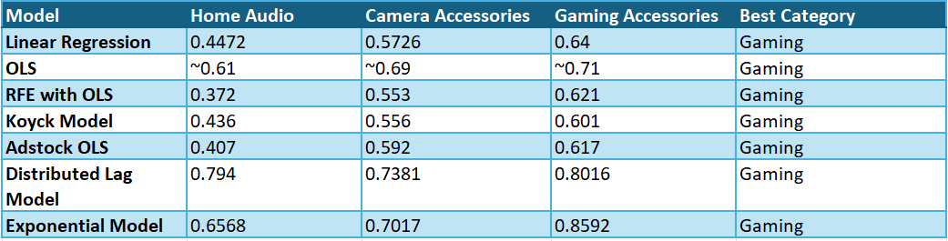
Figure : Model Performance Comparison (R² Test Values)

Business Insights Across Categories
- Discounting: In all models and categories, higher discount percentages demonstrated a negative correlation with GMV. This was most strongly evident in Gaming Accessories, where premium perception is most critical.
- Lag Effects: Lagged GMV and media metrics (e.g., gmv_lag1, LP_lag_2_per) were strong predictors, especially in Home Audio and Gaming, illustrating that past performance and campaigns drive future sales.
- Product Subtypes: Specific products like DJController, Gaming Keyboard, Camera Tripod, and FlashShoeAdapter were strong drivers. This shows targeting high-impact SKUs through campaigns.
- Adstock Variables: TV and online commercials exhibited late but enduring effects. Adstock transformations increased model accuracy, especially for Home Audio and Gaming.
- Delivery and Operations: Delivery delays impacted GMV negatively, while SLA compliance and early/on-time delivery supported higher sales. Procurement indicators like PO_lag_1_per and inc_PO_MA1 impacted GMV indirectly.
- Mass Market Items: 'Mass Market' items were in steady poor performance in GMV contribution, which may reflect commoditisation concerns or perceived lower value.

Category Comparison: Why Gaming Accessories Lead
Linear and multiplicative correlations between variables and GMV were strong. Product categories have distinct identities (e.g., Joysticks, Gaming Mice), making campaigns more effective. Higher MRP products with high price and improved margins. Effective lagged responses to marketing well forecasted by DLM and adstock models.

Gaming Accessories strategic emphasis can provide best ROI. Premium pricing, product bundling, and pre-planned lag-aware campaigns will benefit marketing strategies.

Visual Insight Summaries (EDA Support)
GMV Trends Over Time: Seasonal peaks at Weeks 10, 18, and 41 strongly correlated with promotions, confirming campaign effectiveness.
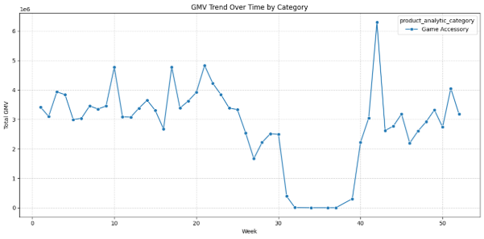
Figure : GMV Trend Over Time By Category

- Price vs. GMV Scatter: The upward correlation, especially sharp up to ₹10,000 MRP, indicates elasticity in the premium segments.
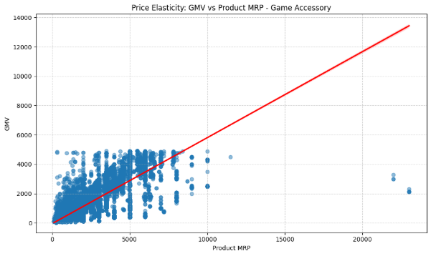
Figure : Price Elasticity: GMV vs Product MRP
- Discount vs. GMV: Larger discounts led to lower GMV, corroborating earlier regression results.

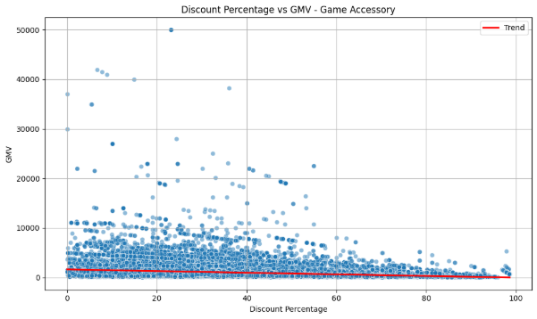
Figure : Discount % vs GMV
- These trends validate the statistical findings and confirm the consistency in business behaviour.

Strategic Recommendations
Based on the insights from several models particularly the Exponential/Multiplicative and Distributed Lag Models, this section offers specific, data-driven marketing and operational suggestions for F-Kart. The aim is to simplify campaign planning, pricing, inventory, and media investment to maximise GMV while improving efficiency and ROI.

Segment-Specific Strategy: Priority to Gaming Accessories
Gaming Accessories was the best overall across all models, outforecasting Home Audio and Camera Accessories on predictive accuracy, interpretability, and responsiveness to marketing. The high R² of 0.8592 for Exponential model illustrates the robustness of the relationships between marketing activities, pricing actions, and sales performance in this category.

Recommended Actions:

- Invest Heavily in Gaming Accessories Promotions: Allocate a larger share of the media budget particularly in television and digital media to Gaming Accessories. Their clear positive response to media stimuli and product-specific features like GamePads, Gaming Headsets, and Gaming Keyboards make this category a great growth driver.
- Avoid Excessive Discounting: Discount percent was inversely related to GMV across all models in this category. Avoid deep discounts and emphasize value-based messaging in advertising to prevent perceived quality from being diluted. Ideal discounting can be considered on the basis of the scenario planning below.
- Bundle High-GMV Products: Bundle best-sellers like GamePads with high-value items like Joysticks or Gaming Keyboards in short-duration bundles. This can help improve average order value without resorting to heavy discounting.

Lag-Aware Campaign Planning Across Categories
Success of Distributed Lag Models and characteristic of incorporating lagged predictors in Koyck and exponential models confirm that marketing efforts typically have a 1–3 week lagged impact on GMV.
Recommended Actions:
- Adopt a Lag-Aware Marketing Calendar: Pre-plan and launch media campaigns 2–3 weeks ahead of significant sales events or celebrations (e.g., Diwali, New Year). Utilize predictive models to anticipate demand peaks and schedule spend respectively.
- Track Lag KPIs Weekly: Keep an eye on variables like gmv_lag1, LP_lag_2_per, and inc_LP_MA1 in real-time. Create dashboards that reflect week-on-week change in these metrics to make agile budgetary adjustments.
- Enable Campaign Memory with Adstock: Continue to use adstock-transformed variables in internal dashboards to forecast decaying campaign effect. This helps in smart re-targeting and reduces media wastage.

Pricing and Discount Strategy
Pricing and discount variables were consistent drivers of GMV. Discount_Percentage had negative coefficients across all product categories and models, whereas MRP (Maximum Retail Price) had positive effects in multiplicative models quite often.
Recommended Actions:
- Move to Premium Positioning: In Home Audio and Gaming, high-MRP products (Sound Mixers, Gaming Keyboards, etc.) were associated with higher GMV. Avoid discounting them; instead, focus on quality, specs, and value in marketing.
- Run Targeted Discount Promotions in Camera Accessories: Since Camera Accessories showed marginal positive effects for subcategories like Tripods and Flash Adapters, consider offering limited, strategic discounts on only these subcategories to spur demand.
- Use Tiered Pricing for Mass Market Products: Products categorized as "Mass Market" underperformed in all categories. Consider staged discounts or packaging them as "value combos" along with premium products.

Product-Centric Targeting
OLS and RFE models revealed some product subcategories to continuously have an effect on GMV.

Top Performers:

- Gaming: GamePads, Gaming Keyboards, Motion Controllers
- Home Audio: DJ Controllers, Sound Mixers, HiFi Systems
- Camera Accessories: Tripods, Flash Shoe Adapters, Camera Lenses
Recommended Actions:
- Maximize High-Impact Products in Campaigns: Prioritize ad creatives and landing pages for high-contribution items to which the models revealed.
- Create Vertical-Specific Landing Pages: For Gaming and Camera Accessories, design dedicated landing pages for vertical niches. This increases relevance and conversion, especially during campaign execution.
- Use Predictive Inventory Management: Utilize lag variables (PO_lag_1_per, gmv_lag_1) to forecast demand for such items and balance procurement accordingly. Ensure high-GMV products are never out of stock during campaign periods.

Media Investment Optimization

TV and digital levers (in their adstocked versions) were similarly found to exert significant influence on GMV, though with lagged influence.

Recommended Actions:
- Balance Media Mix with ROI Estimates: Maintain spend evenly between TV and digital but apply MMM models to estimate future ROI for each media type. For instance, if TV adstock is effective in Gaming but weak in Camera Accessories, redistribute accordingly.
- Use Budget Simulations: Leverage model coefficients to simulate the impact of a raise or reduction in media spend on GMV. This allows decision-makers to plan reallocations based on ROI rather than gut feel.
- Pilot and A/B Test Spend Patterns: Use low-frequency tests (e.g., week-long spend bursts) to test with experimentation how changes in spend across channels drive GMV. Continuously calibrate model predictions and refine.

Operational Enhancements
Operational key metrics like delivery time, SLA, and procurement lag also indicated the effect on GMV.

Recommended Actions:
- Improve On-Time Delivery Metrics: Segments like Gaming and Camera Accessories showed GMV dips when delivery took more time. Monitor logistics and adherence to SLA during high demand weeks.
- Align Campaign Planning with Inventory Status: Avoid campaigns for low stock or slow-procurement items. Use PO_lag_1_per to predict delay in delivering orders and adjust campaigns accordingly.
- Optimize for Prepaid Orders: Prepaid orders were strongly positively correlated with GMV in Camera Accessories. Consider adding small incentives (e.g., free shipping) for prepaid buyers.

Dashboard and Automation
The dynamic nature of lagged effects and campaign outcomes makes it essential to monitor changes weekly.

Recommended Actions:
- Build a Weekly KPI Dashboard: Include real-time tracking of lagged variables, GMV trends, media investments, and product category performance.
- Automate Forecast Updates: Use the DLM and exponential model coefficients in a live forecasting engine to update demand projections weekly.
- Enable Managerial Alerts: Set alerts for significant drops in top-performing variables like units sold, product MRP, or TV adstock levels to ensure proactive decision-making.

Category-Specific Summaries

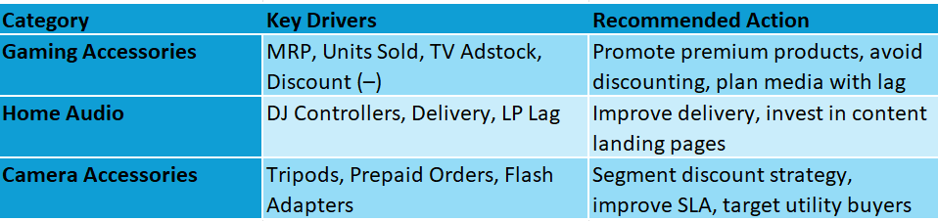
Figure 5: Category Specific Summaries

Limitations and Future Work
While this project offers valuable insights into marketing performance using Marketing Mix Modelling (MMM), there are several limitations that must be acknowledged. These limitations impact both the accuracy and generalisability of the results and point toward important areas for future enhancement.

Modelling Assumptions and Simplifications
The regression models used particularly OLS and Exponential/Multiplicative models assumed relatively simple relationships between variables. For example, the log-log form in the exponential model assumes a constant elasticity of GMV with respect to each input, which may not always hold in practice. Real-world marketing dynamics can often be nonlinear, interactive, and context-specific. Effects like channel synergy, thresholds, or diminishing returns may follow S-shaped or plateauing curves rather than strict log-based trends (Bricker, 2024).
Similarly, the models assumed that the influence of each marketing channel is independent and additive, which ignores possible interaction effects. For instance, TV and online ads may be more effective when run together (synergy), but such interactions were not modelled explicitly due to data and complexity constraints.

Lag and Adstock Handling
While we modelled time-delayed effects using lag variables and adstock transformations, the decay parameters in adstock were set based on industry heuristics rather than optimized through calibration. This may have led to under- or over-estimation of long-term marketing impact. Additionally, models such as Distributed Lag and Koyck focused primarily on short-term lags (1–3 weeks), however, certain campaigns especially in Home Audio might yield longer-term benefits not captured here.

Data Constraints
The analysis was limited to one year of weekly data, which may not fully capture seasonal or macroeconomic influences such as major holidays, inflation, or competitor actions. External factors like market trends or consumer sentiment were not included, which may affect the accuracy of GMV predictions. Also, while product types were detailed, user-level behavioural data (e.g., repeat purchases, cart abandonment) was unavailable due to privacy limitations.

Future Directions
- To overcome these limitations, future work can explore:
- Machine learning models (e.g., XGBoost, Bayesian MMM) for non-linear and interaction-rich modelling
- Bayesian hierarchical modelling to integrate prior knowledge and improve parameter estimation across product categories
- Multi-touch attribution (MTA) integration where user-level data is available, for campaign-level precision
- Seasonality and competitor modelling by including external variables like Google Trends or market reports
- Incorporating these elements can help create a more flexible, dynamic, and business-aligned MMM framework for long-term strategic planning.

References
- Bricker, Z. (2024). Marketing mix modeling for marketers: How to measure marketing in a privacy-first world. Supermetrics Blog. Available at: https://supermetrics.com/blog/marketing-mix-modeling
- DataCamp. (2024). Decoding Marketing Mix Modeling: A Complete Guide. Available at: https://www.datacamp.com/tutorial/decoding-marketing-mix-modeling-a-complete-guide
- Gartner. (2024). Magic Quadrant for Marketing Mix Modeling Solutions. Available at: https://www.gartner.com/en/marketing/topics/marketing-mix
- Lilien, G. L., Kotler, P., & Moorthy, K. S. (1992). Marketing Models. Englewood Cliffs, NJ: Prentice Hall.
- NielsenIQ. (2020). 5 reasons why a Marketing Mix Model is relevant today. Available at: https://nielseniq.com/global/en/insights/commentary/2020/5-reasons-why-a-marketing-mix-model-is-relevant-today
- Supermetrics. (2024). How Marketing Mix Modeling helps you optimize marketing ROI. Available at: https://supermetrics.com/blog/marketing-mix-modeling

Appendix
Python Code link : https://colab.research.google.com/drive/1giZS54ubcNn6BJXQA37jPk-SkIO99Bsa?usp=sharing#scrollTo=XRHXipK8Jehl

